Our Ref: _______________ Your Ref: ________________________ Date: __________________

Baptist Church

Baale Yaku Site Area, P. O. Box 644,

Ogbomoso, Oyo State. Tel. 07052425407

Email: [newsprinbaptistchurch@gmail.com](mailto:newsprinbaptistchurch@gmail.com)

Website: newspringbc.comze.com

NEW SPRING

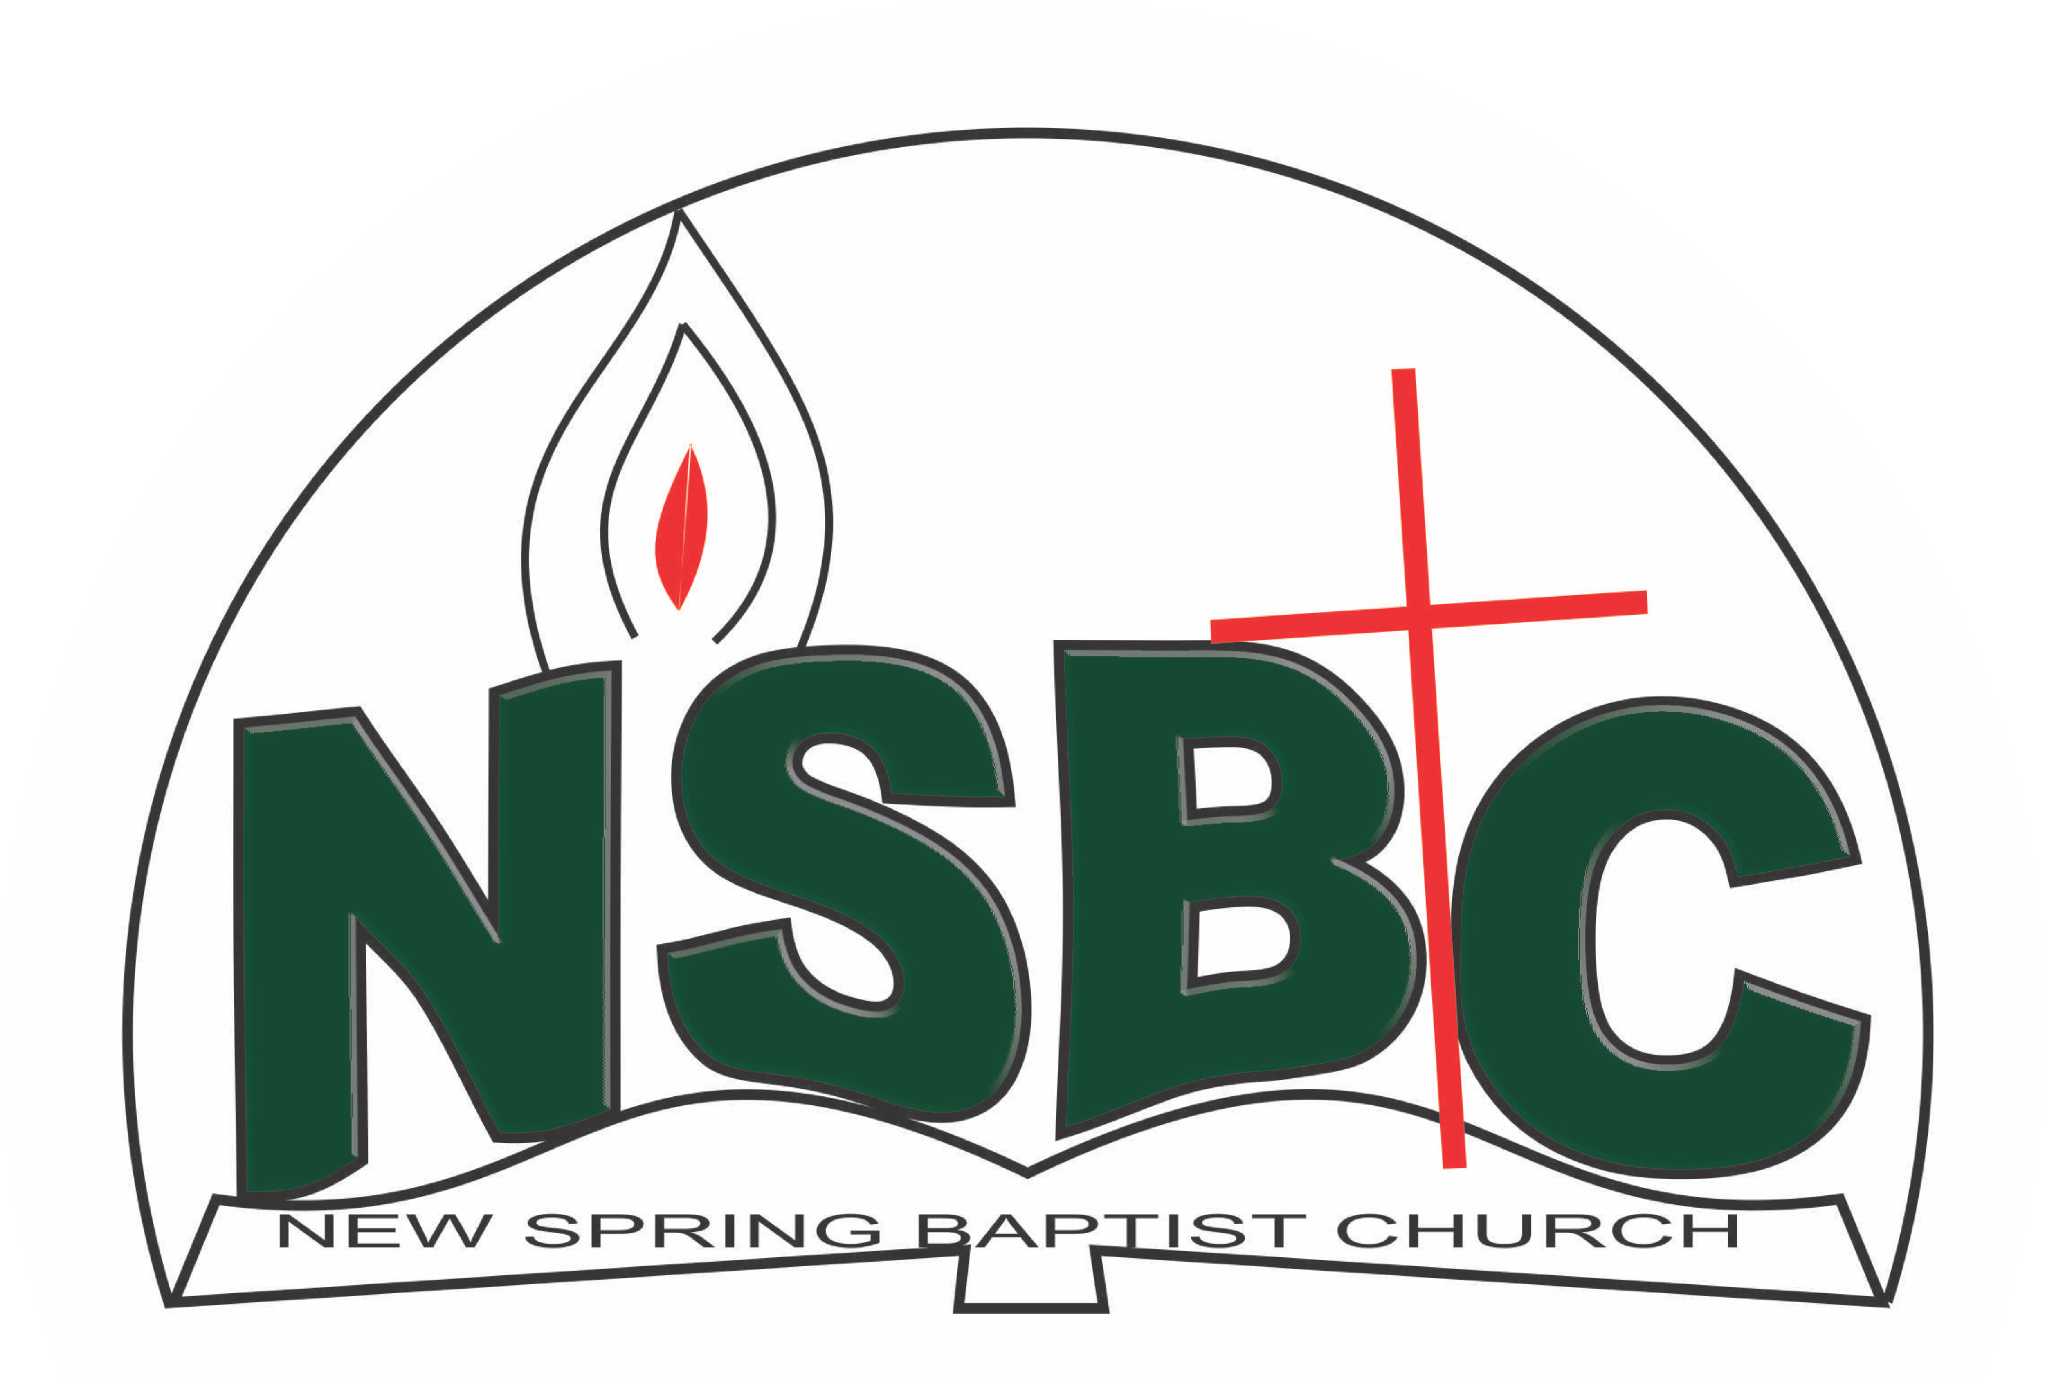

9 January 2022

Dear Dn. Ezekiel Ayinde,

Nomination to Serve as an Officer and Worker in the Church in 2022.

Calvary greetings in the precious name of our Lord and Saviour Jesus Christ. It is our pleasure to inform you that at the Church-in-Conference held on December 19, 2021; the Church ratified your nomination to serve in the following areas between January 1 and December 31, 2022:

1. Treasurer/Ex-Officio, Men’s Missionary Union (MMU)
2. Member, Benevolence Committee under the chairmanship of Dn Dele Olatubosun
3. Member, Intercessor Committee assisted by Mrs Funke Oyekunle
4. Member, Membership Committee under the chairmanship of Mr. Johnson Olaniran
5. Chairman, Mission & Evangelism Committee
6. Chairman, Nominating Committee
7. Deacons
8. Member, Church Council

Please refer to the table below for the key functions of each of these roles. Details can be found in the Church constitution. You are strongly encouraged to become familiar with the tasks as stated in the document. There will be an orientation of the Church workers on January 22, 2022 at 8:30 a.m. on the church premises. Please ensure you participate in this training.

“Now it is required that those who have been given a trust must prove faithful. I Corinthians 4:2”. May God find you faithful in the task He has assigned to you.

| Domain | Key function of Office, Department or Committee |
| --- | --- |
| Treasurer/Ex-Officio, MMU | To provide support to the MMU President in ensuring that the men of the Church are moving forward with the Great Commission and breaking new frontiers/ keeping money & its records |
| Benevolence Committee | The committee is responsible for the implementation of the benevolence policy of the Church. |
| Intercessor Committee | The committee is responsible for standing in the gap on behalf of the Church and her members |
| Membership Committee | The committee is responsible for the overall management of the membership of the Church. |
| Mission & Evangelism | The committee is responsible for the mobilization of Church members for soul winning activities. |
| Member, Nominating Committee | The Nominating Committee shall coordinate the staffing of all Church leadership positions that are filled by volunteers. |
| Deacons[1] | To provide support to the Church Pastor in the effective ministry of the Church to its members, those under spiritual watch care of the Church and the community at large |
| Church Council | The Church Council is the governing body of the Church whose membership, under the leadership of the Holy Spirit, holds one another mutually accountable with respect and love and sees to the smooth running of the Church. |

Thank you for accepting to serve in this Church.

Yours in His service

Olusayo Okediji Blessed Agboola

Church Secretary                                                                                     Chairman, Nominating Committee

1Deacons are elected in the first instance for 5 years (so you will serve till 2023)

1. Deacons are elected in the first instance for 5 years (so you will serve till 2023) but your role as Chairman can change before 2023